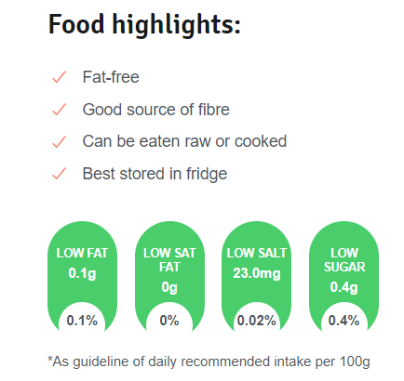

**Lettuce(Salad)**

A green salad made with crispy, crunchy lettuce complements grilled meat, chicken or fish dishes. Depending on the variety, lettuce contains vitamins A and C and minerals such as potassium.

## Why lettuce is good to eat

* Lettuce is an excellent source of vitamin A (the greener the leaves, the more vitamin A present).
* Depending on the variety, lettuce is also a good source of vitamins C and K (important for helping your blood to clot) and folate.
* Lettuce also contains minerals such as potassium (which helps to regulate blood pressure), manganese (involved in the regulation of brain and nerve function), copper and iron (essential for red blood cell formation).
* Energy – 100 g of iceberg lettuce supplies 40 kJ (cos lettuce supplies 80 kJ).